Unit 12: Autopsies and Human Remains
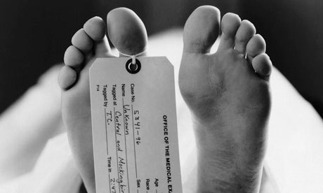

By the end of the unit, you will be able to:
- Describe how autopsies are used to determine cause of death
- Describe the process medical examiners use to determine cause and time of death
- Describe how insects can be used to determine cause of death
- Describe how skeletal remains can be used to identify a victim and cause of death
- Describe the process of decomposition

Unit Vocabulary:
- Autopsy:
______________________________________________________________________________
- Livor mortis:
______________________________________________________________________________
- Rigor mortis:
______________________________________________________________________________
- Algor mortis:
______________________________________________________________________________
- Entomology
______________________________________________________________________________
- Stages of Decomposition:
______________________________________________________________________________
- Forensic anthropologist: ______________________________________________________________________________

What is Death?
- Death is the ______________ or ________ of life.
- It is characterized by ___________ stopping of blood ____________ and ________ activity.
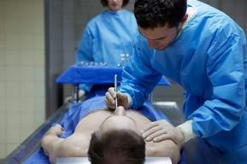
- When the heart stops beating, __________ is deprived from body cells and they begin to die, a process known as _________________.

What is an Autopsy?
- In cases of suspicious or unnatural death, a pathologist conducts post-mortem examination, called an __________.
  - Autopsies are conducted to determine the:
    - __________ of death- means by which they died
    - ________ of death- the reason they died
    - _______________ of death- specific body failure
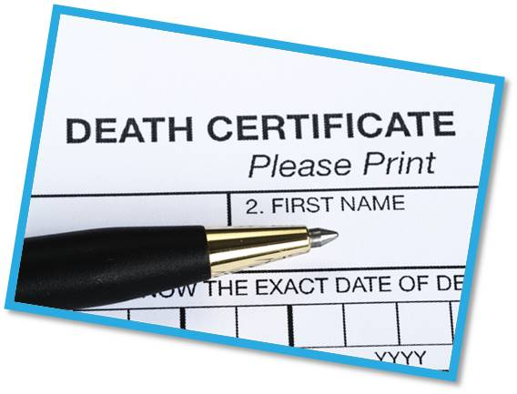
    - _______ of death- when they died

Manner of Death
- Five categories of manner of death can appear on death certificates:
  - ________________
  - ________________
  - ________________
  - ________________
  - ________________

Cause and Mechanism
- Cause of death (COD) is the __________ a person died.
  - _________________ causes include disease, cancer, physical injury, stroke, heart attack etc.
  - Homicidal and suicidal causes include __________, ____________, poisoning, hanging, drowning, suffocation, etc.
- _____________ cause of death' refers to an __________ cause of death, as opposed to the final cause.
  - For example, if someone is exposed to large amount of radiation then develops _____________, the proximate cause of death is exposure to radiation.
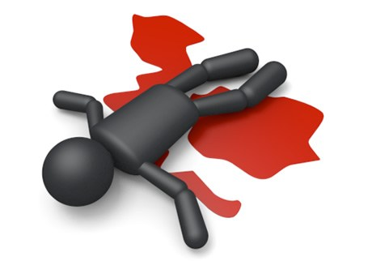
- Mechanism of death describes the specific ___________ in the body that brought about the cessation of life.
Mechanism of Death Examples
- If someone has been shot, they may die from ______of blood, called exsanguination (___________ to death).
- If someone has a heart attack, they may die from ____________ arrest (heart stopping).
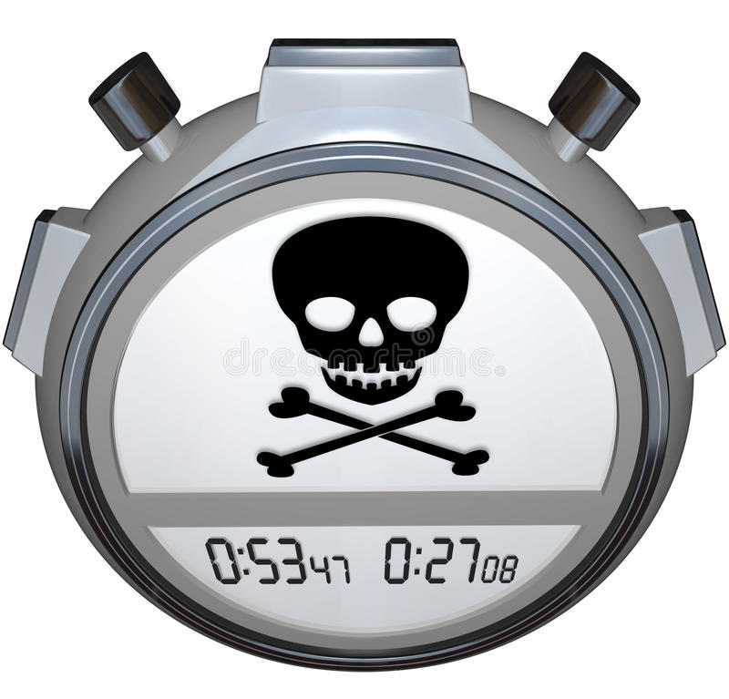
- If someone is strangled, they may die from asphyxiation (lack of _____________).
Time of Death
- During an autopsy, the forensic examiner wants to determine _______ the person died.
- A time of death helps forensic detectives include or _____________ suspects based on their __________ or location at that time.
Types of Mortis
- ______________________ Death color – pooling of blood in tissues after death (lividity)
- ______________________ Death Stiffness – stiffening of skeletal muscles after death.
- ______________________ Death Heat – cooling of body after death.

Livor Mortis
- As body decomposition begins, blood ________ in the lower parts of the victim’s body. Red blood cells break and release _____________, which turn _________ as they spill out of cells. Wherever these _________ of blood settle, the skin takes on the purple coloring.
- The pooling of blood is known as ___________.
  - Begin _________ after death.
  - Between 2-8 hours after death, the color will disappear when the skin is _________ on.
  - After 8 hours, the discoloration becomes ____________.
- Livor mortis not only helps approximate time of death, but also indicates the _____________ of the body during the first 8 hours of death.
  - For example, if all discoloration is on the front of the body, it indicated the person was lying face _________.
  - Discoloration on many parts of the body can show that a body was ________ from one location/position to another.

Rigor Mortis
- It is caused by lack of oxygen to cells and __________ buildup in the ____________, causing stiff muscles and joints.
- Rigor mortis begins in the head about __________ after death, and slowly works down the body and legs.
  - Stiffness peaks at about ____ hours.
  - As the cells _________ during autolysis, the stiffness will slowly disappear.
  - Stiffness completely disappears around _____ hours.
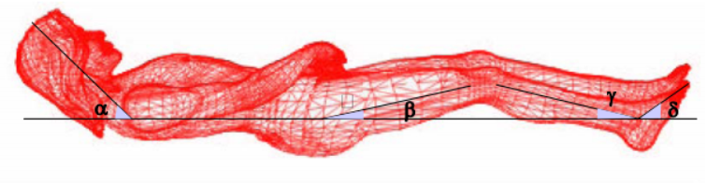
- A dead body that is not stiff has probably been dead less than 2 hours or more than _____ hours.

Algor Mortis
- Describes a body’s temperature ______ after death.
- When a person is alive, the body maintains ________________ and regulates a ___________ temperature.
- After death, the body no longer can maintain its heat and it begins to _________ down.
- To record the temperature of a corpse, forensic investigators insert a thermometer into the __________.
- A body cools at a rate of about _______ degrees per hour immediately after death, then slows to _______ degrees per hour after about 12 hours, until it reaches the _________ temperature as the environment.
Forensic Anthropology
- ____________________________________ analyze skeletal remains to determine the identity of a victim as well as his/her life history, cause of death, or other clues about a crime.
- Main Characteristics:
  - ___________ - Determined by examining the skull, pelvis, humerus, and femur
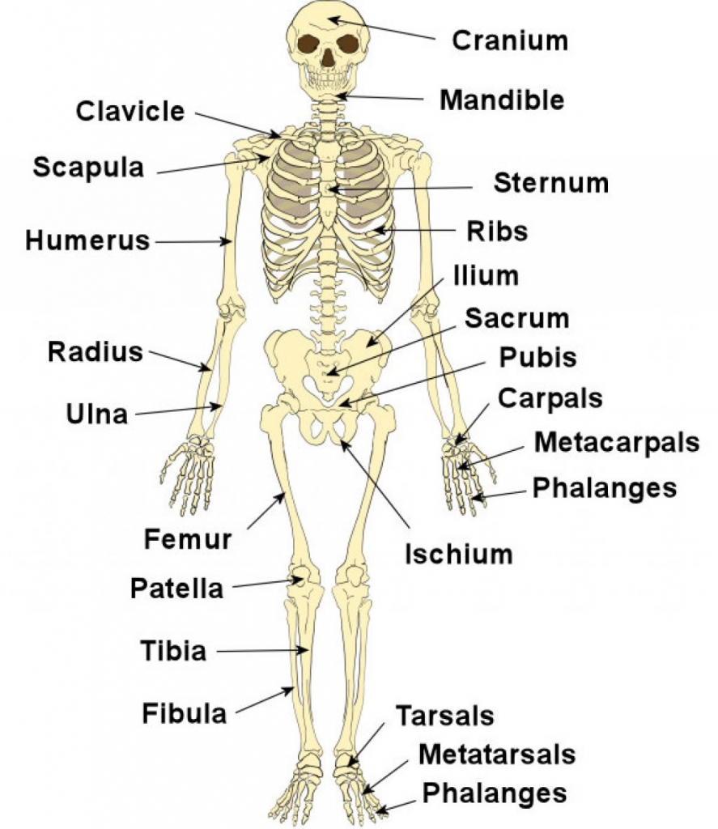
  - ___________ and _________________ (height/build) – Determined by analyzing the development of the teeth, bone growth, cranial suture lines, and the length of specific bones, such as the femur.
  - ______________ – Determined by analyzing the skull for characteristics that are common among people of different races.
What Can the Bones Tell Us?
- ___________________________ can be collected from bone, teeth, and hair to provide clues to a person’s identity.
- Scientists may also be able to gain clues as to a person’s past, recent ____________, or the ________________________ based on bone fractures and other signs of trauma.
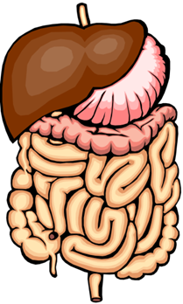
Effects of Death on the Body
- Stomach and Intestinal Contents
  - Time of death can also be estimated by looking at the digestive tract and its contents.
  - It takes about:
    - 4–6 hours for the ___________________ to empty its contents into the small intestine
    - _________ hours for the food to leave the small intestine.
    - 24 hours from the time a meal is eaten until all undigested food is released from the ____________ intestines
  - The location of food in the digestive tract helps scientists estimate how long after a person _______, that they died.
- Changes in the Eye
  - Following death, the surface of the eyes ___________________.
  - If the eyes were open at death, a thin ___________ will appear on the eyes in 2-3 hours. If the eyes are closed, it takes about _______ hours for this film to appear.

Forensic Entomology
- Insects are so useful in crime investigation there is a whole branch devoted to it called forensic ____________________.
- Duties of a forensic entomologist are to:
  - Record detailed crime scene ________________ (temperature, moisture, wind)
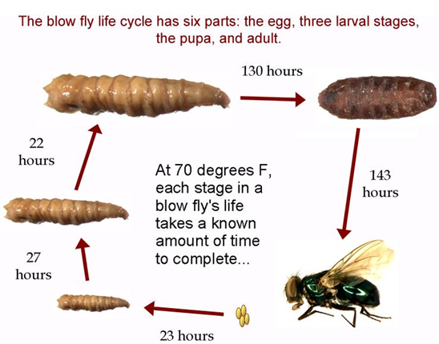
  - Collect ________________ evidence on, above, below, and surrounding the corpse
  - Determining an estimate for the postmortem interval or PMI (the time between death and the discovery of the body)
- If insects from another region are found on a corpse, it suggests that the corpse may have been _________________ and provide important evidence to determine a _____________________ crime scene.
- _____________________ in court to explain insect-related evidence found at the crime scene
- The first stages of decomposition give off an ____________ which attracts insects to lay their _____________ on the body within minutes od death
  - Ex. _____________________ are one of the first insects to arrive at a body
  - Their four stages of development are:
    - ______________
    - ________________/instar1 larva/instar 2 larva/instar 3
    - _________________
    - _________________
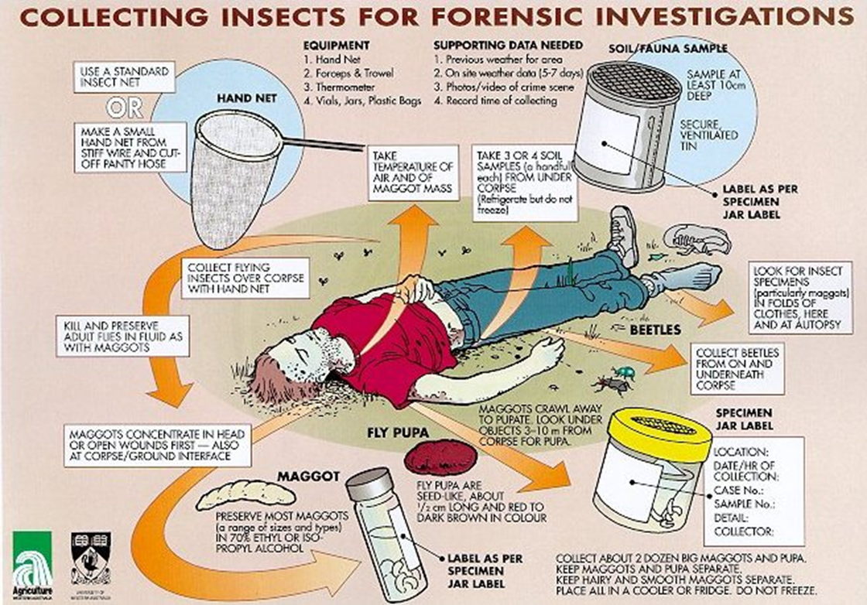

Why are Insects Used in Forensic Science?
- In most seasons and environments, insects _______________ a dead body almost immediately after death
- Their ___________________________________ and species dynamics over time can be used to accurately determine time since death.
- After _________________, entomological evidence is the most accurate method to determine the elapsed time since death.
- Scientists have collected information on ________________ of development at given temperatures for all types of insects known to feed on corpses. This allows forensic entomologists to estimate ______________________________ based on insect evidence gathered at a crime scene.

What Can Insects Tell You?
- _______________________ interval
- Whether the body was ________________ after death
- Whether the body was ___________________
- Presence and position of wound sites
- If the victim used ______________ or was ____________________
- Length of time of abuse or neglect in living victims

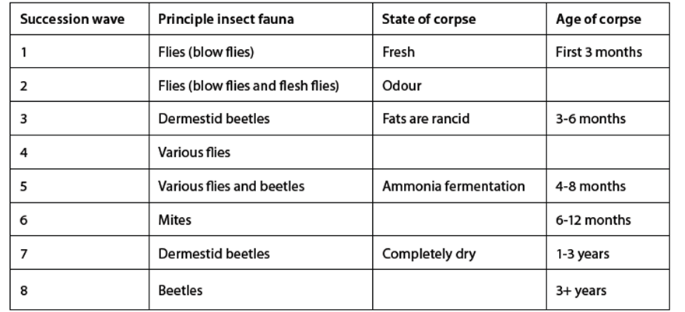
Body Farm
- The University of Tennessee Anthropological Research Facility, nicknamed the “______________________”, investigates human decomposition. Bodies are placed in different settings throughout the facility and left to decompose. The bodies are exposed in a number of ways in order to provide insights into decomposition under ______________________ conditions.

What are the Stages of Decomposition
- Bodies begin to decompose shortly after death and do so in five predictable stages:
  - __________________
  - __________________ or Putrefaction
  - _____________________________ or Black Putrefaction
  - _____________________________
  - _____________________________ or Skeletonization

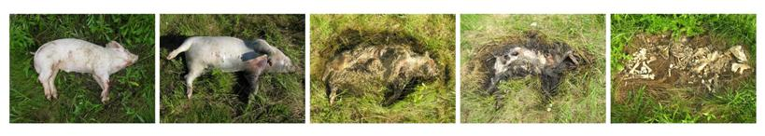
Stages of Decomposition: Fresh
- Begins almost ___________________ after death.
- Livor, rigor, and algor ________________ occur.
- Autolysis, or self-_________________, begins as lysosomes break down and release their digestive ______________________ into the cell.
- Visible changes caused by decomposition are limited during the fresh stage, although autolysis may cause __________________ to appear at the surface of the skin.
Stages of Decomposition: Bloat/Petrification
- This stage of death is mostly due to the activities of ____________________________; first intestinal flora, then saprophytic bacteria and fungi.
- Characterized by the production of ________________ which gives rise to the ___________________ appearance of the decomposing body and strong __________.
- Skin turns a ________________ color as blood decomposes.
- Skin may break apart and _______________ can flow out from the openings.

Stages of Decomposition: Active Decay
- This stage is recognizable by a great loss in ______________, due largely to feedings by ___________________ and other insects. Parts of flesh may be ____________ and corpse gives off an even stronger odor.
- As gases escape and the body leaks decomposition fluids, the body may ____________________.
- The end of this stage is marked by the _____________________ of the maggots from the body.

Stages of Decomposition: Advanced Decay
- The body begins to __________ and preserve itself; most of the _____________ is gone.
- Odor and insect activity ___________________.
- Body may form a ______________ layer known as the adipocere.
Stages of Decomposition: Dry Remains
- Final stage
- Recognizable by a loss of everything on the body but dried up ____________.

What Effects the Speed of Decomposition?
- ____________
  - Young decompose faster than elderly.
- ____________ of body
  - Overweight people decompose faster than average.
- _____________________
  - Naked decompose faster than clothed.
- _________________
  - Sick decompose faster than healthy.
- _______________________ Conditions
  - Bodies decompose fastest in ______________ ºF

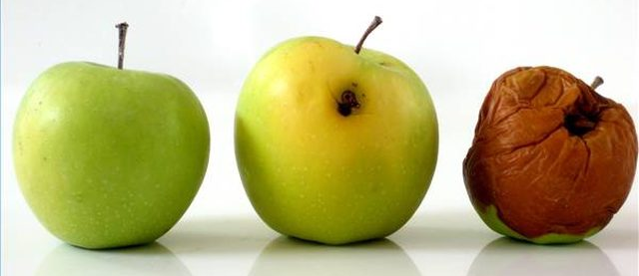
Daily YOYO Sheet
Week of: _____________________________
Directions: Write the answer to the YOYO in the correct box below.
Date:__________________

Date:__________________

Date:__________________

Date:__________________

Date:__________________

Daily YOYO Sheet
Week of: _____________________________
Directions: Write the answer to the YOYO in the correct box below.
Date:__________________

Date:__________________

Date:__________________

Date:__________________

Date:__________________

