Fibers As Evidence; Pre-Lab
Read the following information about fibers and use it to help you answer your Pre-Lab Worksheet Questions.
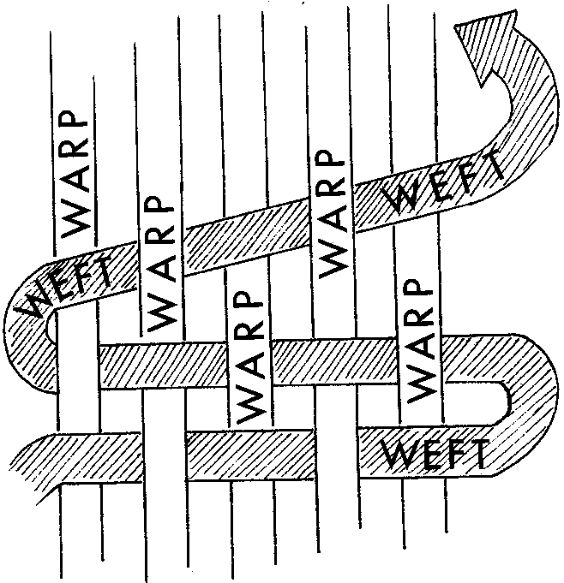
A fiber is composed of many filaments twisted or bonded together to form a thread or yarn, which can be used to manufacture carpet, fabric, paper, rope, and many other items. A filament is a single strand of indefinite length, which twists with other filaments to make a fiber. In forensic science, fibers are classified as either natural (animal, plant, or mineral) or synthetic (man-made).
Fibers can be spun together into yarn, then weaved together to make a fabric textile. In a textile weave, a lengthwise yarn is called a warp. It is usually stronger, smoother, and has a tighter twist than the weft. A weft is the crosswise yarn. Clothing manufacturers can choose different colors, diameters, and/or types of fabrics for the warp and weft, resulting is a blended fabric.
Fiber is chosen for clothing based of the characteristics and properties of the fiber. For example, Nylon is very durable and lightweight. Acrylic is inexpensive, but tends to ball easily. Today, clothing is often made of a blend of fibers, based on the needs of the garment.
Some common fibers include:
Fiber | Type | Classification | Source | Chemical Description
Acetate | Synthetic | Regenerated Fiber | Cellulose esters | Altered Cellulose
Acrylic | Synthetic | Synthetic Polymer | Man-made | Polyacrylonitrile
Cotton | Natural | Plant | Plant seed | Cellulose
Fiberglass | Natural | Mineral | Sand | Silica
Hair | Natural | Animal | Mammals | Protein
Linen | Natural | Plant | Plant stem | Cellulose
Nylon | Synthetic | Synthetic Polymer | Man-made | Polyamide
Polyester | Synthetic | Synthetic Polymer | Man-made | Polyaromatic esters
Rayon | Synthetic | Regenerated Fiber | Cellulose esters | Regenerated Cellulose
Silk | Natural | Animal | Silkworm (Insect) | Protein
Spandex | Synthetic | Synthetic Polymer | Man-made | Polyurethanes
Wool | Natural | Animal | Sheep | Protein

Like hair, fibers are considered class evidence. Fibers lack individuality because they are mass-produced. For example, between 2006 and 2008, textile mills in the United States spun approximately 5 million bales of cotton. That's enough cotton to make over 1 billion pairs of jeans.
All fibers, both synthetic and natural, are considered polymers. Polymers can be examined for both physical and chemical characteristics. Physical characteristics include color, texture, and diameter. Chemical properties include burning (oxidation) and thermal and chemical decomposition. Any characteristics that can aid in narrowing the origin of the fiber to a limited number of sources, will greatly improve the value of the evidence.
Fibers are also considered a form of trace evidence that can be transferred from the clothing of a suspect to the clothing of a victim during the commission of a crime. Fibers can also transfer from a fabric source such as a carpet, bed, or furniture at a crime scene. These transfers can either be direct (primary) or indirect (secondary). A primary transfer occurs when a fiber is transferred from a fabric directly onto a victim's clothing, whereas a secondary transfer occurs when already transferred fibers on the clothing of a suspect transfer to the clothing of a victim. An understanding of the mechanics of primary and secondary transfer is important when reconstructing the events of a crime.
When fibers are matched with a specific source (fabric from the victim, suspect, and/or scene), a value is placed on that association. This value is dependent on many factors, including the type of fiber found, the color or variation of color in the fiber, the number of fibers found, the location of fibers at the crime scene or on the victim, and the number of different fibers at the crime scene or on the victim that match the clothing of the suspect.
Whether a fiber is transferred and detected is dependent on the nature and duration of contact between the suspect and the victim or crime scene, the persistence of fibers after the transfer, and the type(s) of fabric involved in contact. Certain types of fabric do not shed well (donor garments), and some fabrics do not hold fibers well (recipient garments). The construction and fiber composition of the fabric, the duration and force of contact, and the condition of the garment with regard to damage are important considerations.
Another important consideration is the length of time between the actual physical contact and the collection of clothing items from the suspect or victim. If the victim is immobile, very little fiber loss will take place, whereas the suspect's clothing will lose transferred fibers quickly. The likelihood of finding transferred fibers on the clothing of the suspect a day after the alleged contact may be remote, depending on the subsequent use or handling of that clothing. As a result, early collection of fiber evidence is critical. Most fiber evidence falls off or is lost within 24 hours of the transfer.
Real Life Case Using Fiber Evidence - Fairfax County, Virginia in 1989
Five year old Melissa Brannen disappeared from a Christmas party on December 3, 1989. Witness accounts pointed police to Cal Hughes, who left the party around the time of the disappearance, but denied being involved.
Police searched Hughes home and found the clothes from the party in the washing machine. They also searched his car and found countless hairs and fibers.
When she disappeared, Melissa was wearing a Red dress with Big Bird on the front, red tights, and a blue acrylic sweater. Forensic detectives learned the dress was somewhat uncommon, being sold only in JC Penny stores. Fibers from the car were compared to a similar Bird Bird dress from JC Penny and were ruled to have common origin. Detectives also found a few black rabbit hairs in the car. Melissa’s mother had a dyed rabbit coat, which Melissa liked to pet and play with. Detectives also found a blue fiber in the car. They searched Melissa’s bedroom and found a blue fiber that was similar to the one from the suspect’s car. With this evidence, Hughes was taken to court. The association of fibers linked Melissa and the suspect’s car, and was enough for a successful prosecution. Hughes was charged with kidnapping with intent to defile. He was convicted and sentenced to 50 years in prison. To this day, Melissa Brannen’s body has not been found.

