Equilibrium & Le Châtelier’s Principle
YOYO: Where have you heard the word equilibrium before? What do you think it means? Write down your thoughts.
____________________________________________________________________________________________________________________________________________________________________________________________________
Irreversible vs. Reversible Reactions
- In an _________________________________, the reactants react to form the products, which cannot change back into reactant
- A _________________________________, is one in which the conversion of reactants to products and the conversion of products to reactants occur simultaneously (at the same time).
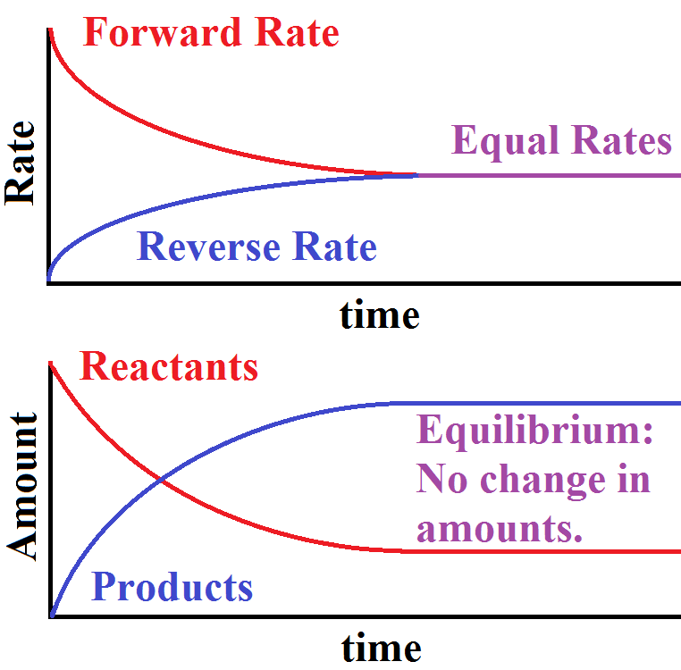
Equilibrium
- Equilibrium occurs when the forward and reverse reactions occur at the ____________________________; the _________________________ of the reactants and products remain ___________________________.
- Can only occur in a _____________________system; reactants nor products can leave the system.
- The forward reaction will continue to slow as the reverse reaction proceeds until equilibrium is met.
  - That is chemical equilibrium.

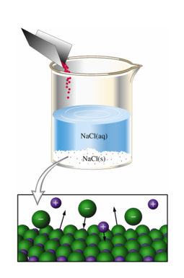
Physical/Phase Equilibrium
- The ________________ at which a substance evaporates is __________________to the _________________________which the substance condenses.
  - Example: Rate of melting = rate of freezing

Solution Equilibrium
- A saturated solution is at equilibrium; the rate of _______________________equals the rate of _________________________________.
  - Ex: NaCl(s) NaCl(aq)

Chemical Equilibrium
- Chemical equilibrium is when the __________________ of the forward and reverse reactions are ___________________ in a chemical reaction.
  - Making ammonia – The Haber process (N₂ + 3H₂ 2NH₃)
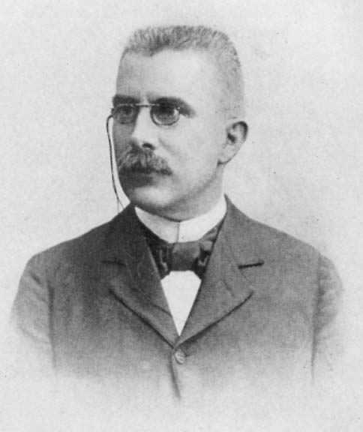
Le Châtelier’s Principle
- Explains how a chemical reaction at equilibrium responds to relieve any stress on that reaction. ______________________________________
- Reaction will counter the stress by shifting to the left to produce more reactant or shift to the right to produce more product.
- Sources of Stress:
  - Changes in _________________________ (amount)
  - Changes in _________________________ (added/subtracted heat)
  - Changes in _________________________ (only if gases are present)

Putting It All Together
- _______________________________________
- _______________________________________
- _______________________________________
- _______________________________________
- ___________________________________________________________________________________________
- ______________________________________________________________________________________________________________________________________________________________________________________
- __________________________________________________________________________________________
- All of this can be boiled down to four letters… AATT
  - A__________ A______________ T_______________________ T_______________________

